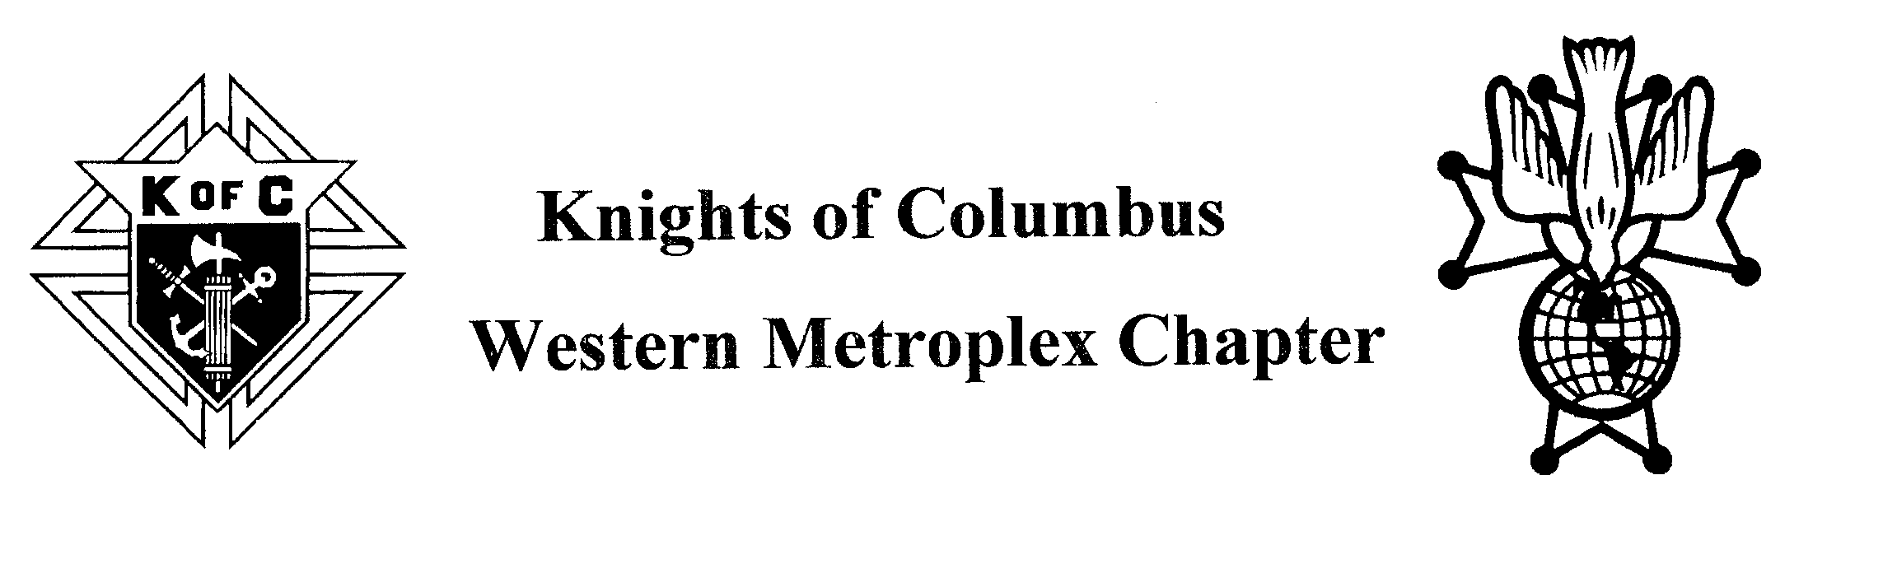
29th Annual Priest and Religious Appreciation Dinner
Monday, July 22, 2024
St. Elizabeth Ann Seton
2016 Willis Ln.
Keller, Texas
5:30pm – Social & Silent Auction, Dinner 7:00pm – Program Starts
Brother Knights,
The dinner this year will be MONDAY, July 22. Tickets will need to be purchased NO LATER THAN WEDNESDAY, July 17th. Tickets need to be purchased through each council, at the Chapter or mailed to me directly with this order form. All tickets will be at the registration table for pick up if not handed out ahead of time. A Council can order a set amount of tickets and the Grand Knight or designee can pick them up and hand them out to his council members. Or the individual (couple) who purchased the ticket(s) will pick them up under their name as listed in the order form below. No tickets will be sold at the door. We encourage each council to purchase tickets for their Priests, Sisters, Deacons, and Seminarian that are members of their parish. If you do purchase their tickets, please list their names on this form and notate their title. There will only be room for 400 people.
$30 Per Person / Table Sponsor $100
Please order your tickets by July 17, 2024

NAME | Council Number | Number of Tickets | Total
Table Sponsor - $100
Total:
Please use back side or make a copy of this form for additional tickets
Make Checks Payable to: Western Metroplex Chapter
Mail this form with the check to: Pat Henz
7420 Gibson Cemetery Rd.
Mansfield, TX 76063
For further information, contact Pat Henz 817-501-5197 pghenz@yahoo.com

